

Mehran University of Engineering and Technology Jamshoro

**ASSIGNMENT : LAB 07&08**

**SUBJECT : PROGRAMMING FUNDAMENTALS**

**ROLL NO : 24BSAI29**

**SUBMITTED BY : SYED MUHAMMAD QASIM**

**SUBMITTED TO : MA’AM FAHAMA BARKZAI**

|  |
| --- |
| Department of Software Engineering  Mehran University of Engineering and Technology, Jamshoro |

|  |  |  |  |
| --- | --- | --- | --- |
| Course: AI-112 – Programming Fundamentals | | | |
| Instructor | Engr. Fahama Barakzai | **Practical/Lab No.** | 07-08 |
| Date |  | **CLOs** | 3 |
| Signature |  | **Assessment Score** | 02 Marks |

|  |  |
| --- | --- |
| Topic | Working with Structures and Enumerations in C++ |
| Objectives | * To become familiar with User-defined datatypes – Structures in C++. * To work with Enumerations in C++. |

|  |
| --- |
| Lab Discussion: Theoretical concepts and Procedural steps |

**TOOLS: TURBOO C++/ DEV C++/ VS-CODE/ CODE BLOCKS**

|  |
| --- |
| Lab Tasks |

1. Create a Structure called employee that contains two members:

an employee number (type int) and the employee’s salary (type int).

Ask the user to fill this data for two employees, store it in two variables of type struct employee, and then display the information for each employee.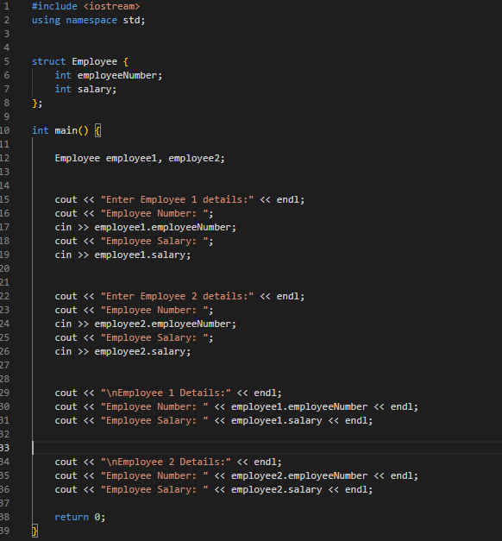

**Output of the program is:**

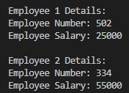

1. Create a Structure called Students that contains two members:

student’s obtained marks type(int), total marks (type int).

Ask the user for obtained marks and total marks, store it in a variable of type struct student, and then display the percentage.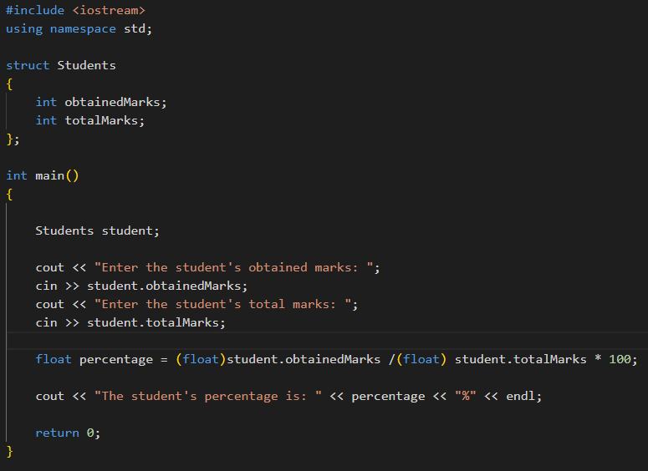

**Output of the program is:**

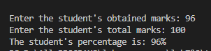

1. Rebuild a C++ program of your own choice that demonstrates the use and working of nested structures.

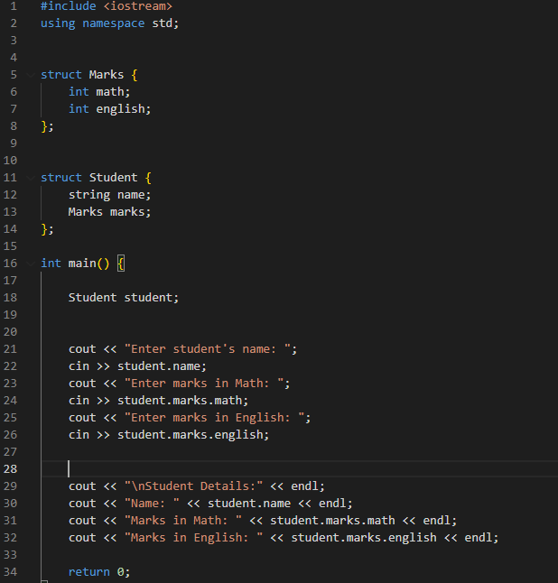

**Output of the program is:**

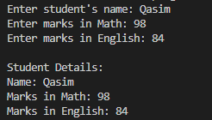

1. Practice a C++ program to store the name (type string), account number (type int) and balance of a customer. Write a function to print data of the customer.

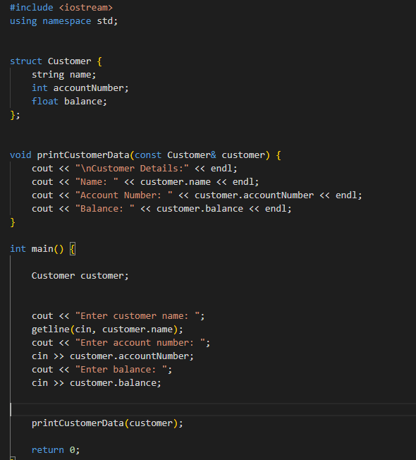

**Output of the program is:**

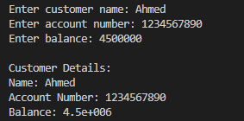

1. Practice a program that defines a structure Address with five fields: name (type string), street (type string), city (type string), state (type string), and zip (type int).

Declare a variable address1 of type Address. Prompt the user to enter a name, a street, a city, a state, and a zip code for address1, and then print these values to the console.



